Application: Large-Scale Image Merge System
Course Outcome Assessment – I
CSA0619 – DESIGN AND ANALYSIS OF ALGORITHMS
Submitted by

M Yasodha Krishna (192472100)
Under the Supervision of

Dr. F. Mary Harin Fernandez

ABSTRACT
Large-scale image processing applications handle millions of images that must be efficiently divided, processed, and merged. Recursive algorithms are commonly used because they reduce a large problem into smaller subproblems. This report analyzes a recursive image merge system using the recurrence relation T(n) = T(n/2) + n. The substitution method is applied to derive the time complexity, and the algorithm's growth rate is analyzed using asymptotic notation. The analysis shows that the algorithm performs linear work overall and is suitable for processing large image datasets efficiently.

INTRODUCTION
Image processing systems are widely used in medical imaging, satellite imaging, computer vision, and multimedia applications. These systems often divide a large image dataset into smaller parts for faster processing. After processing, the smaller datasets are merged to produce the final output. The efficiency of such systems depends on the recursive algorithm used during division and merging. Design and Analysis of Algorithms helps evaluate the performance of these recursive techniques by determining their time complexity using recurrence relations.

PROBLEM STATEMENT
A large-scale image processing system recursively divides an image dataset into two equal halves. At each recursive level, additional linear work is required to merge the processed datasets. The recurrence relation representing this algorithm is
T(n) = T(n/2) + n
The objective is to solve this recurrence using the substitution method, determine the overall time complexity, analyze the growth rate for large image datasets, and express the result using asymptotic notation.

OBJECTIVES
- To understand the divide-and-conquer approach used in image processing.
- To solve the recurrence relation using the substitution method.
- To analyze the algorithm's execution time.
- To determine the asymptotic complexity.
- To study the scalability of the algorithm for large datasets.

SYSTEM DESCRIPTION
The proposed image merge system receives a large image dataset as input. The dataset is recursively divided into two equal parts until a single image remains. During the return phase of recursion, the images are merged by performing linear work at each level. This recursive strategy reduces problem size while maintaining efficient processing. The recurrence relation models the execution time of the system.

ALGORITHM
- Start the algorithm.
- Read the number of images n.
- If n ≤ 1, stop recursion.
- Divide the dataset into two equal halves.
- Recursively process one half.
- Perform linear merge work on the processed images.
- Continue until all recursive calls finish.
- Expand the recurrence relation using substitution.
- Compute the total work.
- Determine the asymptotic complexity.
- Stop.

RECURRENCE RELATION
The execution time of the recursive image merge system is represented by
T(n) = T(n/2) + n
where
- T(n/2) represents the recursive processing of half of the image dataset.
- n represents the linear merging cost at each recursive level.

SUBSTITUTION METHOD
Given,
T(n) = T(n/2) + n
Expanding recursively,
First Expansion
T(n) = T(n/4) + n/2 + n
Second Expansion
T(n) = T(n/8) + n/4 + n/2 + n
Third Expansion
T(n) = T(n/16) + n/8 + n/4 + n/2 + n
After k expansions,
T(n) = T(n/2ᵏ) + n(1 + 1/2 + 1/4 + ...)
The recursion stops when
n/2ᵏ = 1
Therefore,
k = log₂ n
The geometric series converges to a constant value less than 2.
Hence,
T(n) = Θ(n)

IMPLEMENTATION
The algorithm is implemented in Python using recursion. The program simulates recursive division of the image dataset and calculates the merge cost at each recursive level. The implementation demonstrates how the recurrence relation behaves during execution and validates the theoretical complexity obtained using the substitution method.
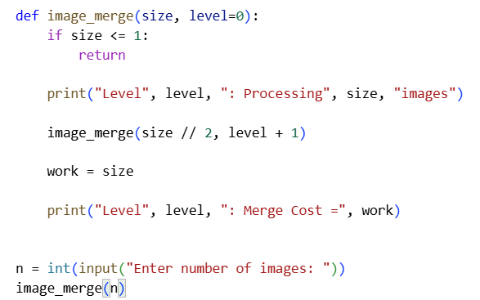

INPUT
The program accepts the number of images as input.
Example
16

OUTPUT
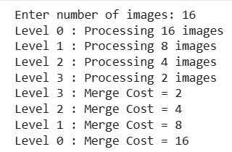

RESULT ANALYSIS
The recursive algorithm successfully divides the image dataset into smaller parts and performs linear merge work during each recursive return. Although the recursion depth is logarithmic, the total work performed forms a geometric series whose sum is proportional to the input size. Therefore, the overall execution time increases linearly as the number of images increases.

COMPLEXITY ANALYSIS
Parameter | Complexity
Best Case | Θ(n)
Average Case | Θ(n)
Worst Case | Θ(n)
Space Complexity | Θ(log n)

APPLICATIONS
- Medical image processing
- Satellite image analysis
- Computer vision systems
- Image stitching applications
- Cloud-based image storage systems
- Digital photo management

ADVANTAGES
- Efficient recursive processing
- Simple divide-and-conquer strategy
- Linear overall time complexity
- Suitable for large datasets
- Easy to implement and analyze

LIMITATIONS
- Uses recursive function calls, increasing memory usage.
- Stack overflow may occur for extremely large recursion depths.
- Performance depends on efficient merge operations.

CONCLUSION
The recurrence relation T(n) = T(n/2) + n was successfully solved using the substitution method. The expansion of the recurrence forms a geometric series, resulting in a linear time complexity of Θ(n). The analysis confirms that the recursive image merge system scales efficiently for large image datasets and is suitable for applications requiring fast image processing.

REFERENCES
- Thomas H. Cormen, Introduction to Algorithms, MIT Press.
- Ellis Horowitz, Fundamentals of Computer Algorithms.
- Alfred V. Aho, The Design and Analysis of Computer Algorithms.
- Lecture Notes on Design and Analysis of Algorithms.

